Quadrotor UAV Control – State Space Design and Sensor Delay Analysis.

- Introduction

This report presents modelling and control of quadrotor UAV using a linearized state-space approach. Quadrotors are inherently unstable system which required active feedback control for stable flight.

The objective is to study the effects of sensor delay in reference tracking and disturbance stabilization by designing a controller for altitude and pitch stabilization. The MATLAB Control System Toolbox is used throughout for analysis and simulation.

- System Modelling

- State Vector Definition

A reduced order model is used for capturing altitude and pitch. In the full 12-state quadrotor model, x and y positions are assumed to be constant. Also, the roll and yaw dynamics are assumed to be constant, which makes the velocities in the respective directions to be zero.

The state vector is defined as:

$$x={\left[z, \dot{z, } θ, q\right]}^{T}$$

where z and θ are the vertical position and pitch respectively.

- Assumptions

- Linearized around the hover equilibrium: θ =0, q =0, ż =0, T=mg
- Small angle approximation: cos(θ) ≈ 1, sin(θ) ≈ 0
- Roll and yaw are held constant and decoupled from pitch and altitude

- Linearized State Space Matrices

The linearized system takes the standard form: ẋ = Ax + Bu, y = Cx + Du

A = $\left[\begin{matrix}0 & 1 & 0 & 0 \\ 0 & 0 & 0 & 0 \\ 0 & 0 & 0 & 1 \\ 0 & 0 & 0 & 0\end{matrix}\right]$ B = $\left[\begin{matrix}0 & 0 \\ 1/m & 0 \\ 0 & 0 \\ 0 & 1/Iyy\end{matrix}\right]$

C =$\left[\begin{matrix}1 & 0 & 0 & 0 \\ 0 & 1 & 0 & 0 \\ 0 & 0 & 1 & 0 \\ 0 & 0 & 0 & 1\end{matrix}\right]$ D = $\left[\begin{matrix}0 & 0 \\ 0 & 0 \\ 0 & 0 \\ 0 & 0\end{matrix}\right]$

- M (mass) =0.5kg
- I_{yy} (moment of inertia) = 0. 1kg.m²

- System Analysis

- Controllability

The controllability matrix is computed and its rank checked against the system order and was found that the system is fully controllable which means that any state can be driven to any other state in finite time using the available inputs; thrust and torque.

- Observability

Similarly, the observability matrix is computed and found that the system is fully observable which means that all four states can be measured.
- Open Loop Stability

The open loop eigen values are found using damp(A). All four eigenvalues lie at the origin indicating the uncontrolled system is marginally stable.

- Controller Design

- Design Requirements

- Overshoot < 10%
- Rise Time < 2 seconds
- Settling Time < 10 seconds
- Steady-State Error < 2%

- Pole Selection

- Altitude sub-system
Poles: -2.5 ± 1.5j
Damping: 0.86
wn: 2.9 rad/s

- Pitch sub-system
Poles: -3.0, -3.1
Damping: >1.0
Wn: 3.05

The pitch poles are kept more negative than altitude poles because of the standard rule that altitude must be corrected faster than position to prevent drift.

- Reference Tracking

- Problem Statement

The closed loop system A_cl stabilizes the drone at the origin. To drive the drone to a desired state x_d, a feedforward gain (Kd) is required. The control law is

$U=-K\left(x_{o}-x_{d}\right)+K_{d}x_{d}$

- Feedforward Gain

The feedforward gain is generally computed using a pseudo inverse approach, but due to the structure of A, the dc gain is used which gives a 2x2 matrix whose inverse is the feedforward gain

The rows 1 and 3 of the dc gain correspond to the z and θ outputs respectively.

- Tracking System

The system takes the reduced reference $x_{red}=[z,θ]$ as input and applied feedforward transformation.
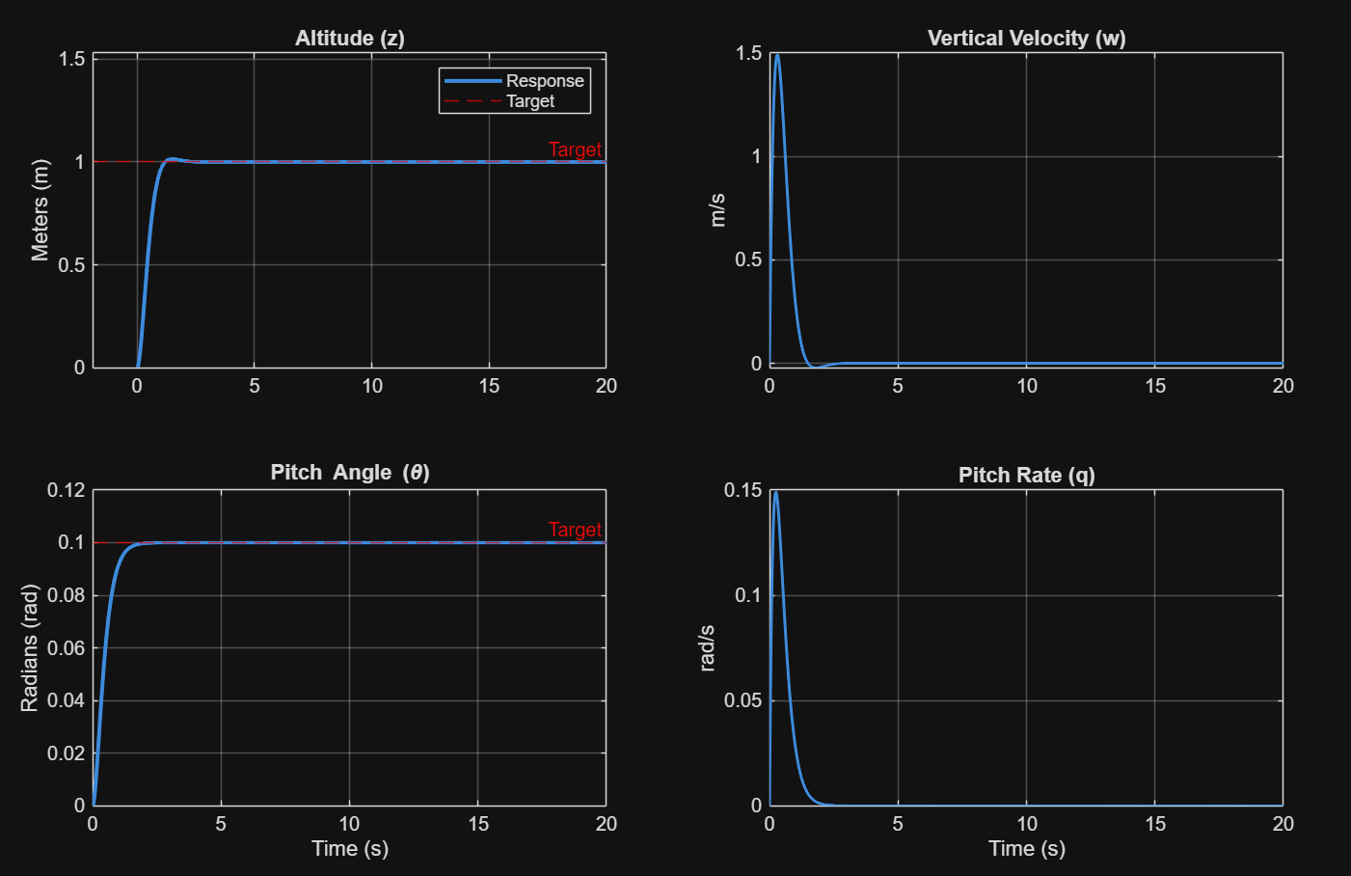
Simulated response of target response

- Disturbance Rejection

- Test Setup
A step disturbance is injected into the altitude matrix between t=4 and 5s which simulates an external force such as a wind gust. The disturbed input is constructed by adding the disturbance signal to the reference input.

- Response
- As the altitude deviates from the target in the disturbance period, the controller detects error and responds.
- System returns to target altitude after the disturbance ends.
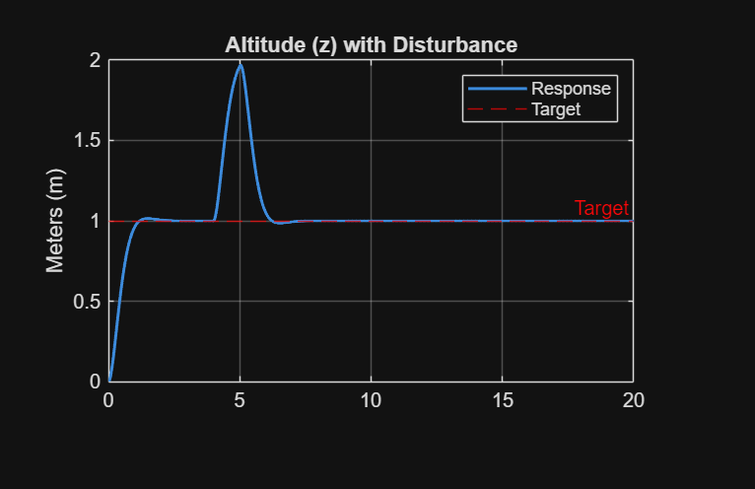
Simulated Response of disturbance modelling

- Sensor Delay Analysis
- Problem Statement
In real UAV systems, sensors do not provide instantaneous measurements. Every sensor used has some delay or latency. When the controller acts on delayed measurements, its correcting for a state which no longer exists, which might cause oscillations or instability.

- Modelling Sensor Dela
Sensor delay is modelled as a pure time delay applied to the systems output. By using the Pade approximation, we can convert this to a rational transfer function.
The delay transfer function is then multiplied to the output of the tracking function or the disturbed input system by pre multiplying the transfer function with the required system.

- Sensitivity Study
A total of six delay values were tested from 0ms till 1000ms split into equal intervals to observe the gradual degradation performance.

- Initial Condition Handling.
The Pade approximation adds internal states to the system. The initial condition vector must match the system order.
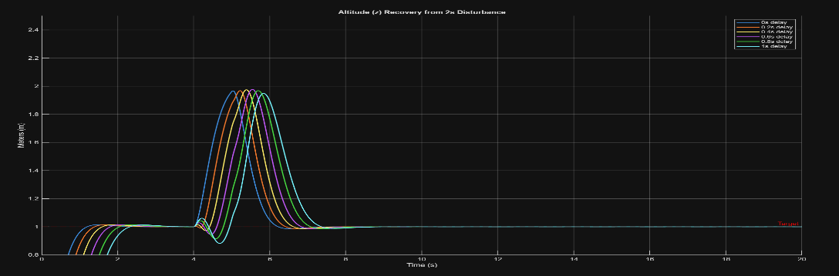
Simulated response of disturbance response under latency
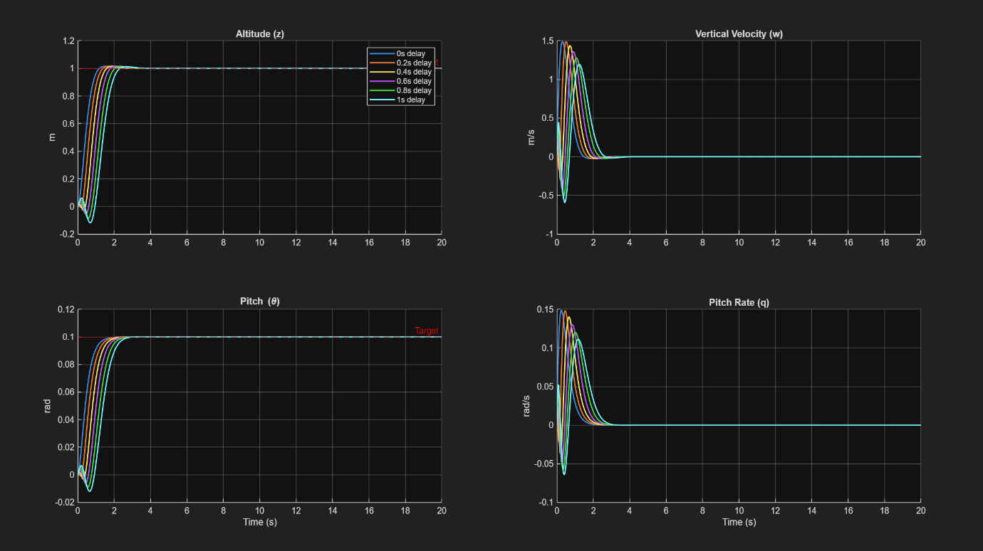
Simulated response of target response under latency
- Performance Verification

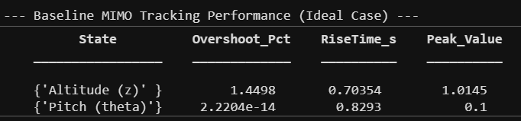
The performance matrices are extracted from simulation data using stepinfo() with the final value as the reference.
